EXAMINE VARIABLES=Index Hindu Muslims GenPopulation SCPopulation STPopulation SCSTPopulation
TeluguUrdu Others CasteDI CasteI CasteIso CasteCR LiteracyDI LiteracyI LiteracyIso LiteracyCR
/ID=Mandal
/PLOT BOXPLOT HISTOGRAM
/COMPARE GROUPS
/STATISTICS DESCRIPTIVES EXTREME
/CINTERVAL 95
/MISSING LISTWISE
/NOTOTAL.

Explore

Notes
Output Created |  | 30-MAY-2020 17:10:06
Comments
Input | Data | /Users/pranjgup/Desktop/Personal/Hyd Project/28 mandals data - 16 may 2020/heat-map-data-all.csv
Input | Active Dataset | DataSet1
Input | Filter | <none>
Input | Weight | <none>
Input | Split File | <none>
Input | N of Rows in Working Data File | 28
Missing Value Handling | Definition of Missing | User-defined missing values for dependent variables are treated as missing.
Missing Value Handling | Cases Used | Statistics are based on cases with no missing values for any dependent variable or factor used.
Syntax |  | EXAMINE VARIABLES=Index Hindu Muslims GenPopulation SCPopulation STPopulation SCSTPopulation  TeluguUrdu Others CasteDI CasteI CasteIso CasteCR LiteracyDI LiteracyI LiteracyIso LiteracyCR  /ID=Mandal  /PLOT BOXPLOT HISTOGRAM  /COMPARE GROUPS  /STATISTICS DESCRIPTIVES EXTREME  /CINTERVAL 95  /MISSING LISTWISE  /NOTOTAL.
Resources | Processor Time | 00:00:05.95
Resources | Elapsed Time | 00:00:06.00

Case Processing Summary
 | Cases
 | Valid |  | Missing |  | Total
 | N | Percent | N | Percent | N | Percent
Index | 24 | 85.7% | 4 | 14.3% | 28 | 100.0%
Hindu | 24 | 85.7% | 4 | 14.3% | 28 | 100.0%
Muslims | 24 | 85.7% | 4 | 14.3% | 28 | 100.0%
GenPopulation | 24 | 85.7% | 4 | 14.3% | 28 | 100.0%
SCPopulation | 24 | 85.7% | 4 | 14.3% | 28 | 100.0%
STPopulation | 24 | 85.7% | 4 | 14.3% | 28 | 100.0%
SCSTPopulation | 24 | 85.7% | 4 | 14.3% | 28 | 100.0%
TeluguUrdu | 24 | 85.7% | 4 | 14.3% | 28 | 100.0%
Others | 24 | 85.7% | 4 | 14.3% | 28 | 100.0%
CasteDI | 24 | 85.7% | 4 | 14.3% | 28 | 100.0%
CasteI | 24 | 85.7% | 4 | 14.3% | 28 | 100.0%
CasteIso | 24 | 85.7% | 4 | 14.3% | 28 | 100.0%
CasteCR | 24 | 85.7% | 4 | 14.3% | 28 | 100.0%
LiteracyDI | 24 | 85.7% | 4 | 14.3% | 28 | 100.0%
LiteracyI | 24 | 85.7% | 4 | 14.3% | 28 | 100.0%
LiteracyIso | 24 | 85.7% | 4 | 14.3% | 28 | 100.0%
LiteracyCR | 24 | 85.7% | 4 | 14.3% | 28 | 100.0%

Descriptives
 |  |  | Statistic | Std. Error
Index | Mean |  | 6.42107822617 | .208358966510
Index | 95% Confidence Interval for Mean | Lower Bound | 5.99005486440
Index | 95% Confidence Interval for Mean | Upper Bound | 6.85210158794
Index | 5% Trimmed Mean |  | 6.46025742723
Index | Median |  | 6.57731735700
Index | Variance |  | 1.042
Index | Std. Deviation |  | 1.020746302568
Index | Minimum |  | 3.947197857
Index | Maximum |  | 8.140160000
Index | Range |  | 4.192962143
Index | Interquartile Range |  | 1.282992536
Index | Skewness |  | -.631 | .472
Index | Kurtosis |  | .033 | .918
Hindu | Mean |  | 67.22749785942 | 4.820139520002
Hindu | 95% Confidence Interval for Mean | Lower Bound | 57.25627955808
Hindu | 95% Confidence Interval for Mean | Upper Bound | 77.19871616075
Hindu | 5% Trimmed Mean |  | 69.08277253176
Hindu | Median |  | 76.00555965500
Hindu | Variance |  | 557.610
Hindu | Std. Deviation |  | 23.613764626056
Hindu | Minimum |  | 9.233819036
Hindu | Maximum |  | 90.603666450
Hindu | Range |  | 81.369847414
Hindu | Interquartile Range |  | 33.331482930
Hindu | Skewness |  | -1.273 | .472
Hindu | Kurtosis |  | .528 | .918
Muslims | Mean |  | 27.46447870075 | 5.126026213655
Muslims | 95% Confidence Interval for Mean | Lower Bound | 16.86048556267
Muslims | 95% Confidence Interval for Mean | Upper Bound | 38.06847183883
Muslims | 5% Trimmed Mean |  | 25.36061652175
Muslims | Median |  | 16.66281639500
Muslims | Variance |  | 630.627
Muslims | Std. Deviation |  | 25.112297263170
Muslims | Minimum |  | 5.107508686
Muslims | Maximum |  | 89.094421580
Muslims | Range |  | 83.986912894
Muslims | Interquartile Range |  | 35.826100290
Muslims | Skewness |  | 1.297 | .472
Muslims | Kurtosis |  | .512 | .918
GenPopulation | Mean |  | 90.7963 | .73466
GenPopulation | 95% Confidence Interval for Mean | Lower Bound | 89.2765
GenPopulation | 95% Confidence Interval for Mean | Upper Bound | 92.3160
GenPopulation | 5% Trimmed Mean |  | 90.8044
GenPopulation | Median |  | 90.8650
GenPopulation | Variance |  | 12.953
GenPopulation | Std. Deviation |  | 3.59909
GenPopulation | Minimum |  | 83.38
GenPopulation | Maximum |  | 98.12
GenPopulation | Range |  | 14.74
GenPopulation | Interquartile Range |  | 4.65
GenPopulation | Skewness |  | -.133 | .472
GenPopulation | Kurtosis |  | -.166 | .918
SCPopulation | Mean |  | 7.5408 | .66487
SCPopulation | 95% Confidence Interval for Mean | Lower Bound | 6.1655
SCPopulation | 95% Confidence Interval for Mean | Upper Bound | 8.9162
SCPopulation | 5% Trimmed Mean |  | 7.4866
SCPopulation | Median |  | 6.9400
SCPopulation | Variance |  | 10.609
SCPopulation | Std. Deviation |  | 3.25716
SCPopulation | Minimum |  | 1.49
SCPopulation | Maximum |  | 14.87
SCPopulation | Range |  | 13.38
SCPopulation | Interquartile Range |  | 3.89
SCPopulation | Skewness |  | .249 | .472
SCPopulation | Kurtosis |  | .245 | .918
STPopulation | Mean |  | 1.6629 | .19429
STPopulation | 95% Confidence Interval for Mean | Lower Bound | 1.2610
STPopulation | 95% Confidence Interval for Mean | Upper Bound | 2.0648
STPopulation | 5% Trimmed Mean |  | 1.6244
STPopulation | Median |  | 1.7150
STPopulation | Variance |  | .906
STPopulation | Std. Deviation |  | .95182
STPopulation | Minimum |  | .36
STPopulation | Maximum |  | 3.66
STPopulation | Range |  | 3.30
STPopulation | Interquartile Range |  | 1.43
STPopulation | Skewness |  | .477 | .472
STPopulation | Kurtosis |  | -.249 | .918
SCSTPopulation | Mean |  | 9.2038 | .73466
SCSTPopulation | 95% Confidence Interval for Mean | Lower Bound | 7.6840
SCSTPopulation | 95% Confidence Interval for Mean | Upper Bound | 10.7235
SCSTPopulation | 5% Trimmed Mean |  | 9.1956
SCSTPopulation | Median |  | 9.1350
SCSTPopulation | Variance |  | 12.953
SCSTPopulation | Std. Deviation |  | 3.59909
SCSTPopulation | Minimum |  | 1.88
SCSTPopulation | Maximum |  | 16.62
SCSTPopulation | Range |  | 14.74
SCSTPopulation | Interquartile Range |  | 4.65
SCSTPopulation | Skewness |  | .133 | .472
SCSTPopulation | Kurtosis |  | -.166 | .918
TeluguUrdu | Mean |  | 86.5314787392 | 1.93694178034
TeluguUrdu | 95% Confidence Interval for Mean | Lower Bound | 82.5246093843
TeluguUrdu | 95% Confidence Interval for Mean | Upper Bound | 90.5383480940
TeluguUrdu | 5% Trimmed Mean |  | 87.7111599470
TeluguUrdu | Median |  | 89.2865187350
TeluguUrdu | Variance |  | 90.042
TeluguUrdu | Std. Deviation |  | 9.48903804660
TeluguUrdu | Minimum |  | 52.79282704
TeluguUrdu | Maximum |  | 96.76464894
TeluguUrdu | Range |  | 43.97182190
TeluguUrdu | Interquartile Range |  | 8.54854031
TeluguUrdu | Skewness |  | -2.332 | .472
TeluguUrdu | Kurtosis |  | 6.550 | .918
Others | Mean |  | 13.46852126071 | 1.936941780331
Others | 95% Confidence Interval for Mean | Lower Bound | 9.46165190589
Others | 95% Confidence Interval for Mean | Upper Bound | 17.47539061553
Others | 5% Trimmed Mean |  | 12.28884005273
Others | Median |  | 10.71348126500
Others | Variance |  | 90.042
Others | Std. Deviation |  | 9.489038046577
Others | Minimum |  | 3.235351061
Others | Maximum |  | 47.207172960
Others | Range |  | 43.971821899
Others | Interquartile Range |  | 8.548540304
Others | Skewness |  | 2.332 | .472
Others | Kurtosis |  | 6.550 | .918
CasteDI | Mean |  | .22205160496 | .025887236941
CasteDI | 95% Confidence Interval for Mean | Lower Bound | .16849977525
CasteDI | 95% Confidence Interval for Mean | Upper Bound | .27560343467
CasteDI | 5% Trimmed Mean |  | .21680656775
CasteDI | Median |  | .18257554150
CasteDI | Variance |  | .016
CasteDI | Std. Deviation |  | .126821042710
CasteDI | Minimum |  | .041086784
CasteDI | Maximum |  | .496943962
CasteDI | Range |  | .455857178
CasteDI | Interquartile Range |  | .192551609
CasteDI | Skewness |  | .753 | .472
CasteDI | Kurtosis |  | -.437 | .918
CasteI | Mean |  | .89670242696 | .005875465799
CasteI | 95% Confidence Interval for Mean | Lower Bound | .88454809992
CasteI | 95% Confidence Interval for Mean | Upper Bound | .90885675400
CasteI | 5% Trimmed Mean |  | .89775571607
CasteI | Median |  | .89908656650
CasteI | Variance |  | .001
CasteI | Std. Deviation |  | .028783786419
CasteI | Minimum |  | .834510588
CasteI | Maximum |  | .940670937
CasteI | Range |  | .106160349
CasteI | Interquartile Range |  | .034622235
CasteI | Skewness |  | -.558 | .472
CasteI | Kurtosis |  | .107 | .918
CasteIso | Mean |  | .10329757308 | .005875465800
CasteIso | 95% Confidence Interval for Mean | Lower Bound | .09114324604
CasteIso | 95% Confidence Interval for Mean | Upper Bound | .11545190013
CasteIso | 5% Trimmed Mean |  | .10224428397
CasteIso | Median |  | .10091343350
CasteIso | Variance |  | .001
CasteIso | Std. Deviation |  | .028783786424
CasteIso | Minimum |  | .059329063
CasteIso | Maximum |  | .165489412
CasteIso | Range |  | .106160349
CasteIso | Interquartile Range |  | .034622235
CasteIso | Skewness |  | .558 | .472
CasteIso | Kurtosis |  | .107 | .918
CasteCR | Mean |  | 1.00000052529 | .000000070815
CasteCR | 95% Confidence Interval for Mean | Lower Bound | 1.00000037880
CasteCR | 95% Confidence Interval for Mean | Upper Bound | 1.00000067178
CasteCR | 5% Trimmed Mean |  | 1.00000049045
CasteCR | Median |  | 1.00000047650
CasteCR | Variance |  | .000
CasteCR | Std. Deviation |  | .000000346919
CasteCR | Minimum |  | 1.000000118
CasteCR | Maximum |  | 1.000001617
CasteCR | Range |  | .000001499
CasteCR | Interquartile Range |  | .000000361
CasteCR | Skewness |  | 1.682 | .472
CasteCR | Kurtosis |  | 3.434 | .918
LiteracyDI | Mean |  | .08070216208 | .007860064482
LiteracyDI | 95% Confidence Interval for Mean | Lower Bound | .06444237988
LiteracyDI | 95% Confidence Interval for Mean | Upper Bound | .09696194429
LiteracyDI | 5% Trimmed Mean |  | .08109980072
LiteracyDI | Median |  | .08566400100
LiteracyDI | Variance |  | .001
LiteracyDI | Std. Deviation |  | .038506294650
LiteracyDI | Minimum |  | .005973237
LiteracyDI | Maximum |  | .145523898
LiteracyDI | Range |  | .139550661
LiteracyDI | Interquartile Range |  | .062952520
LiteracyDI | Skewness |  | -.206 | .472
LiteracyDI | Kurtosis |  | -.739 | .918
LiteracyI | Mean |  | .73127455883 | .008218693110
LiteracyI | 95% Confidence Interval for Mean | Lower Bound | .71427289678
LiteracyI | 95% Confidence Interval for Mean | Upper Bound | .74827622088
LiteracyI | 5% Trimmed Mean |  | .73090920131
LiteracyI | Median |  | .73188144450
LiteracyI | Variance |  | .002
LiteracyI | Std. Deviation |  | .040263208943
LiteracyI | Minimum |  | .644931238
LiteracyI | Maximum |  | .823307036
LiteracyI | Range |  | .178375798
LiteracyI | Interquartile Range |  | .058008675
LiteracyI | Skewness |  | .145 | .472
LiteracyI | Kurtosis |  | .217 | .918
LiteracyIso | Mean |  | .26872544129 | .008218693114
LiteracyIso | 95% Confidence Interval for Mean | Lower Bound | .25172377923
LiteracyIso | 95% Confidence Interval for Mean | Upper Bound | .28572710335
LiteracyIso | 5% Trimmed Mean |  | .26909079882
LiteracyIso | Median |  | .26811855550
LiteracyIso | Variance |  | .002
LiteracyIso | Std. Deviation |  | .040263208964
LiteracyIso | Minimum |  | .176692964
LiteracyIso | Maximum |  | .355068762
LiteracyIso | Range |  | .178375798
LiteracyIso | Interquartile Range |  | .058008675
LiteracyIso | Skewness |  | -.145 | .472
LiteracyIso | Kurtosis |  | .217 | .918
LiteracyCR | Mean |  | 1.00000138267 | .000000184604
LiteracyCR | 95% Confidence Interval for Mean | Lower Bound | 1.00000100078
LiteracyCR | 95% Confidence Interval for Mean | Upper Bound | 1.00000176455
LiteracyCR | 5% Trimmed Mean |  | 1.00000127804
LiteracyCR | Median |  | 1.00000118400
LiteracyCR | Variance |  | .000
LiteracyCR | Std. Deviation |  | .000000904372
LiteracyCR | Minimum |  | 1.000000336
LiteracyCR | Maximum |  | 1.000004645
LiteracyCR | Range |  | .000004309
LiteracyCR | Interquartile Range |  | .000001054
LiteracyCR | Skewness |  | 2.124 | .472
LiteracyCR | Kurtosis |  | 6.599 | .918

Extreme Values
 |  |  | Case Number | Mandal | Value
Index | Highest | 1 | 16 | Ameerpet mandal | 8.140160000
Index | Highest | 2 | 9 | Himayatnagar mandal | 7.581271714
Index | Highest | 3 | 10 | Amberpet mandal | 7.569729000
Index | Highest | 4 | 11 | Charminar mandal | 7.449533286
Index | Highest | 5 | 17 | Balanagar mandal | 7.234619143
Index | Lowest | 1 | 26 | Rajendranagar mandal | 3.947197857
Index | Lowest | 2 | 18 | Quthbullapur mandal | 4.803524000
Index | Lowest | 3 | 23 | Serilingampalle mandal | 5.090684714
Index | Lowest | 4 | 24 | Hayathnagar mandal | 5.181587571
Index | Lowest | 5 | 20 | Keesara mandal | 5.277423000
Hindu | Highest | 1 | 24 | Hayathnagar mandal | 90.603666450
Hindu | Highest | 2 | 20 | Keesara mandal | 89.549772120
Hindu | Highest | 3 | 22 | Uppal mandal | 87.162550180
Hindu | Highest | 4 | 16 | Ameerpet mandal | 86.455053330
Hindu | Highest | 5 | 19 | Malkajgiri mandal | 84.609172310
Hindu | Lowest | 1 | 11 | Charminar mandal | 9.233819036
Hindu | Lowest | 2 | 14 | Bahadurpura mandal | 17.623110150
Hindu | Lowest | 3 | 13 | Bandlaguda mandal | 32.346536720
Hindu | Lowest | 4 | 6 | Golkonda mandal | 33.569711140
Hindu | Lowest | 5 | 7 | Asifnagar mandal | 44.110178210
Muslims | Highest | 1 | 11 | Charminar mandal | 89.094421580
Muslims | Highest | 2 | 14 | Bahadurpura mandal | 80.256879090
Muslims | Highest | 3 | 13 | Bandlaguda mandal | 65.023183410
Muslims | Highest | 4 | 6 | Golkonda mandal | 62.625434130
Muslims | Highest | 5 | 7 | Asifnagar mandal | 52.712282550
Muslims | Lowest | 1 | 20 | Keesara mandal | 5.107508686
Muslims | Lowest | 2 | 24 | Hayathnagar mandal | 5.524329321
Muslims | Lowest | 3 | 16 | Ameerpet mandal | 6.136786863
Muslims | Lowest | 4 | 22 | Uppal mandal | 7.244923149
Muslims | Lowest | 5 | 19 | Malkajgiri mandal | 7.341665639
GenPopulation | Highest | 1 | 11 | Charminar mandal | 98.12
GenPopulation | Highest | 2 | 14 | Bahadurpura mandal | 96.18
GenPopulation | Highest | 3 | 6 | Golkonda mandal | 95.53
GenPopulation | Highest | 4 | 13 | Bandlaguda mandal | 93.98
GenPopulation | Highest | 5 | 7 | Asifnagar mandal | 93.26
GenPopulation | Lowest | 1 | 2 | Maredpally mandal | 83.38
GenPopulation | Lowest | 2 | 28 | Ramachandrapuram mandal | 85.00
GenPopulation | Lowest | 3 | 19 | Malkajgiri mandal | 86.05
GenPopulation | Lowest | 4 | 24 | Hayathnagar mandal | 86.26
GenPopulation | Lowest | 5 | 20 | Keesara mandal | 87.38
SCPopulation | Highest | 1 | 2 | Maredpally mandal | 14.87
SCPopulation | Highest | 2 | 28 | Ramachandrapuram mandal | 12.97
SCPopulation | Highest | 3 | 19 | Malkajgiri mandal | 12.31
SCPopulation | Highest | 4 | 3 | Secunderabad mandal | 10.16
SCPopulation | Highest | 5 | 24 | Hayathnagar mandal | 10.08
SCPopulation | Lowest | 1 | 11 | Charminar mandal | 1.49
SCPopulation | Lowest | 2 | 14 | Bahadurpura mandal | 1.58
SCPopulation | Lowest | 3 | 6 | Golkonda mandal | 4.03
SCPopulation | Lowest | 4 | 13 | Bandlaguda mandal | 4.27
SCPopulation | Lowest | 5 | 17 | Balanagar mandal | 5.10
STPopulation | Highest | 1 | 24 | Hayathnagar mandal | 3.66
STPopulation | Highest | 2 | 16 | Ameerpet mandal | 3.62
STPopulation | Highest | 3 | 25 | Saroornagar mandal | 2.88
STPopulation | Highest | 4 | 20 | Keesara mandal | 2.71
STPopulation | Highest | 5 | 14 | Bahadurpura mandal | 2.24
STPopulation | Lowest | 1 | 8 | Nampally mandal | .36
STPopulation | Lowest | 2 | 11 | Charminar mandal | .39
STPopulation | Lowest | 3 | 6 | Golkonda mandal | .44
STPopulation | Lowest | 4 | 3 | Secunderabad mandal | .54
STPopulation | Lowest | 5 | 9 | Himayatnagar mandal | .58
SCSTPopulation | Highest | 1 | 2 | Maredpally mandal | 16.62
SCSTPopulation | Highest | 2 | 28 | Ramachandrapuram mandal | 15.00
SCSTPopulation | Highest | 3 | 19 | Malkajgiri mandal | 13.95
SCSTPopulation | Highest | 4 | 24 | Hayathnagar mandal | 13.74
SCSTPopulation | Highest | 5 | 20 | Keesara mandal | 12.62
SCSTPopulation | Lowest | 1 | 11 | Charminar mandal | 1.88
SCSTPopulation | Lowest | 2 | 14 | Bahadurpura mandal | 3.82
SCSTPopulation | Lowest | 3 | 6 | Golkonda mandal | 4.47
SCSTPopulation | Lowest | 4 | 13 | Bandlaguda mandal | 6.02
SCSTPopulation | Lowest | 5 | 7 | Asifnagar mandal | 6.74
TeluguUrdu | Highest | 1 | 11 | Charminar mandal | 96.76464894
TeluguUrdu | Highest | 2 | 12 | Saidabad mandal | 94.52508085
TeluguUrdu | Highest | 3 | 13 | Bandlaguda mandal | 93.85480613
TeluguUrdu | Highest | 4 | 25 | Saroornagar mandal | 93.22791819
TeluguUrdu | Highest | 5 | 24 | Hayathnagar mandal | 93.09359801
TeluguUrdu | Lowest | 1 | 8 | Nampally mandal | 52.79282704
TeluguUrdu | Lowest | 2 | 9 | Himayatnagar mandal | 68.65971367
TeluguUrdu | Lowest | 3 | 3 | Secunderabad mandal | 76.53729094
TeluguUrdu | Lowest | 4 | 16 | Ameerpet mandal | 81.91637041
TeluguUrdu | Lowest | 5 | 19 | Malkajgiri mandal | 83.37600731
Others | Highest | 1 | 8 | Nampally mandal | 47.207172960
Others | Highest | 2 | 9 | Himayatnagar mandal | 31.340286330
Others | Highest | 3 | 3 | Secunderabad mandal | 23.462709060
Others | Highest | 4 | 16 | Ameerpet mandal | 18.083629590
Others | Highest | 5 | 19 | Malkajgiri mandal | 16.623992690
Others | Lowest | 1 | 11 | Charminar mandal | 3.235351061
Others | Lowest | 2 | 12 | Saidabad mandal | 5.474919155
Others | Lowest | 3 | 13 | Bandlaguda mandal | 6.145193871
Others | Lowest | 4 | 25 | Saroornagar mandal | 6.772081806
Others | Lowest | 5 | 24 | Hayathnagar mandal | 6.906401989
CasteDI | Highest | 1 | 14 | Bahadurpura mandal | .496943962
CasteDI | Highest | 2 | 13 | Bandlaguda mandal | .458311484
CasteDI | Highest | 3 | 26 | Rajendranagar mandal | .416806419
CasteDI | Highest | 4 | 6 | Golkonda mandal | .381444529
CasteDI | Highest | 5 | 11 | Charminar mandal | .356840271
CasteDI | Lowest | 1 | 16 | Ameerpet mandal | .041086784
CasteDI | Lowest | 2 | 20 | Keesara mandal | .082618064
CasteDI | Lowest | 3 | 23 | Serilingampalle mandal | .096230782
CasteDI | Lowest | 4 | 22 | Uppal mandal | .104407414
CasteDI | Lowest | 5 | 12 | Saidabad mandal | .107133771
CasteI | Highest | 1 | 11 | Charminar mandal | .940670937
CasteI | Highest | 2 | 16 | Ameerpet mandal | .936113138
CasteI | Highest | 3 | 9 | Himayatnagar mandal | .935683757
CasteI | Highest | 4 | 2 | Maredpally mandal | .931777964
CasteI | Highest | 5 | 13 | Bandlaguda mandal | .922245197
CasteI | Lowest | 1 | 3 | Secunderabad mandal | .834510588
CasteI | Lowest | 2 | 19 | Malkajgiri mandal | .834653136
CasteI | Lowest | 3 | 26 | Rajendranagar mandal | .860894497
CasteI | Lowest | 4 | 14 | Bahadurpura mandal | .870179904
CasteI | Lowest | 5 | 20 | Keesara mandal | .873462023
CasteIso | Highest | 1 | 3 | Secunderabad mandal | .165489412
CasteIso | Highest | 2 | 19 | Malkajgiri mandal | .165346864
CasteIso | Highest | 3 | 26 | Rajendranagar mandal | .139105503
CasteIso | Highest | 4 | 14 | Bahadurpura mandal | .129820096
CasteIso | Highest | 5 | 20 | Keesara mandal | .126537977
CasteIso | Lowest | 1 | 11 | Charminar mandal | .059329063
CasteIso | Lowest | 2 | 16 | Ameerpet mandal | .063886862
CasteIso | Lowest | 3 | 9 | Himayatnagar mandal | .064316243
CasteIso | Lowest | 4 | 2 | Maredpally mandal | .068222036
CasteIso | Lowest | 5 | 13 | Bandlaguda mandal | .077754803
CasteCR | Highest | 1 | 12 | Saidabad mandal | 1.000001617
CasteCR | Highest | 2 | 20 | Keesara mandal | 1.000001225
CasteCR | Highest | 3 | 15 | Musheerabad mandal | 1.000000842
CasteCR | Highest | 4 | 3 | Secunderabad mandal | 1.000000839
CasteCR | Highest | 5 | 28 | Ramachandrapuram mandal | 1.000000765
CasteCR | Lowest | 1 | 17 | Balanagar mandal | 1.000000118
CasteCR | Lowest | 2 | 13 | Bandlaguda mandal | 1.000000166
CasteCR | Lowest | 3 | 25 | Saroornagar mandal | 1.000000212
CasteCR | Lowest | 4 | 11 | Charminar mandal | 1.000000236
CasteCR | Lowest | 5 | 22 | Uppal mandal | 1.000000249
LiteracyDI | Highest | 1 | 8 | Nampally mandal | .145523898
LiteracyDI | Highest | 2 | 12 | Saidabad mandal | .145153912
LiteracyDI | Highest | 3 | 25 | Saroornagar mandal | .121612669
LiteracyDI | Highest | 4 | 4 | Khairatabad mandal | .118304023
LiteracyDI | Highest | 5 | 7 | Asifnagar mandal | .115008777
LiteracyDI | Lowest | 1 | 9 | Himayatnagar mandal | .005973237
LiteracyDI | Lowest | 2 | 6 | Golkonda mandal | .022841385
LiteracyDI | Lowest | 3 | 15 | Musheerabad mandal | .027055821
LiteracyDI | Lowest | 4 | 2 | Maredpally mandal | .028190799
LiteracyDI | Lowest | 5 | 14 | Bahadurpura mandal | .047384435
LiteracyI | Highest | 1 | 9 | Himayatnagar mandal | .823307036
LiteracyI | Highest | 2 | 15 | Musheerabad mandal | .794748763
LiteracyI | Highest | 3 | 19 | Malkajgiri mandal | .778068427
LiteracyI | Highest | 4 | 2 | Maredpally mandal | .765082437
LiteracyI | Highest | 5 | 24 | Hayathnagar mandal | .764721695
LiteracyI | Lowest | 1 | 26 | Rajendranagar mandal | .644931238
LiteracyI | Lowest | 2 | 13 | Bandlaguda mandal | .678813185
LiteracyI | Lowest | 3 | 28 | Ramachandrapuram mandal | .686024955
LiteracyI | Lowest | 4 | 12 | Saidabad mandal | .693294368
LiteracyI | Lowest | 5 | 14 | Bahadurpura mandal | .694645122
LiteracyIso | Highest | 1 | 26 | Rajendranagar mandal | .355068762
LiteracyIso | Highest | 2 | 13 | Bandlaguda mandal | .321186815
LiteracyIso | Highest | 3 | 28 | Ramachandrapuram mandal | .313975045
LiteracyIso | Highest | 4 | 12 | Saidabad mandal | .306705633
LiteracyIso | Highest | 5 | 14 | Bahadurpura mandal | .305354878
LiteracyIso | Lowest | 1 | 9 | Himayatnagar mandal | .176692964
LiteracyIso | Lowest | 2 | 15 | Musheerabad mandal | .205251237
LiteracyIso | Lowest | 3 | 19 | Malkajgiri mandal | .221931573
LiteracyIso | Lowest | 4 | 2 | Maredpally mandal | .234917564
LiteracyIso | Lowest | 5 | 24 | Hayathnagar mandal | .235278305
LiteracyCR | Highest | 1 | 12 | Saidabad mandal | 1.000004645
LiteracyCR | Highest | 2 | 20 | Keesara mandal | 1.000002480
LiteracyCR | Highest | 3 | 28 | Ramachandrapuram mandal | 1.000002132
LiteracyCR | Highest | 4 | 2 | Maredpally mandal | 1.000002120
LiteracyCR | Highest | 5 | 16 | Ameerpet mandal | 1.000001954
LiteracyCR | Lowest | 1 | 17 | Balanagar mandal | 1.000000336
LiteracyCR | Lowest | 2 | 19 | Malkajgiri mandal | 1.000000507
LiteracyCR | Lowest | 3 | 25 | Saroornagar mandal | 1.000000566
LiteracyCR | Lowest | 4 | 22 | Uppal mandal | 1.000000576
LiteracyCR | Lowest | 5 | 18 | Quthbullapur mandal | 1.000000642

Index

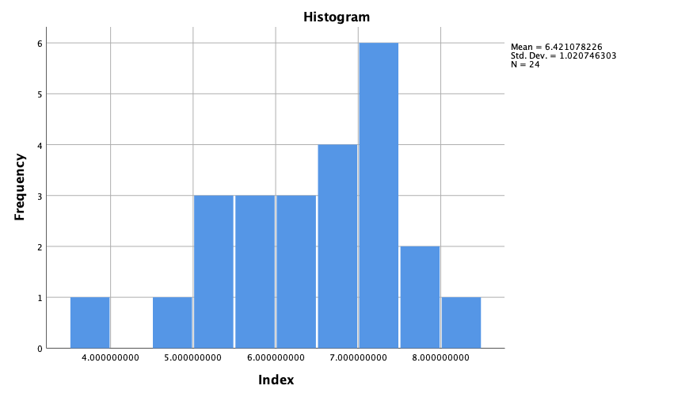

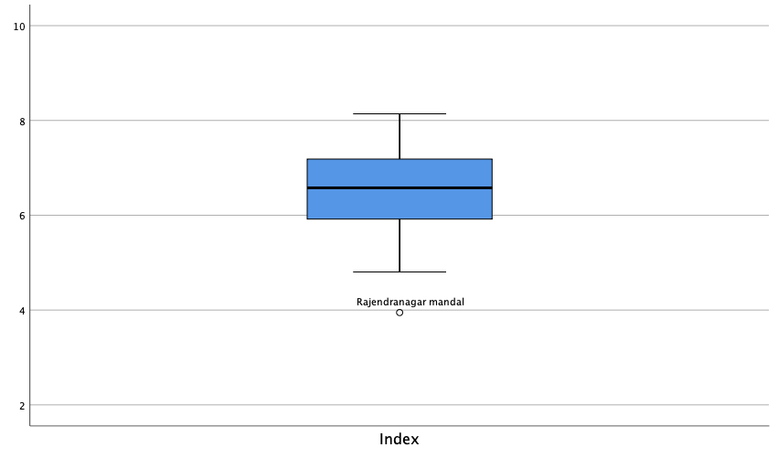

Hindu

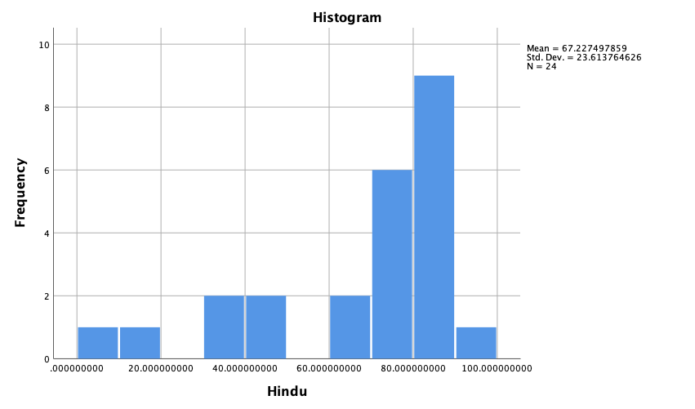

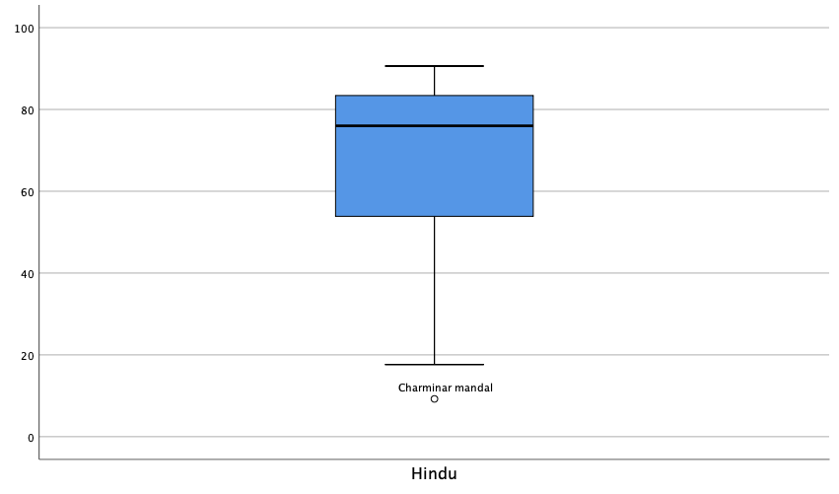

Muslims

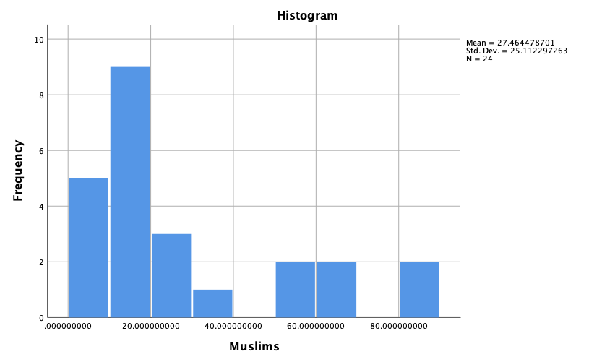

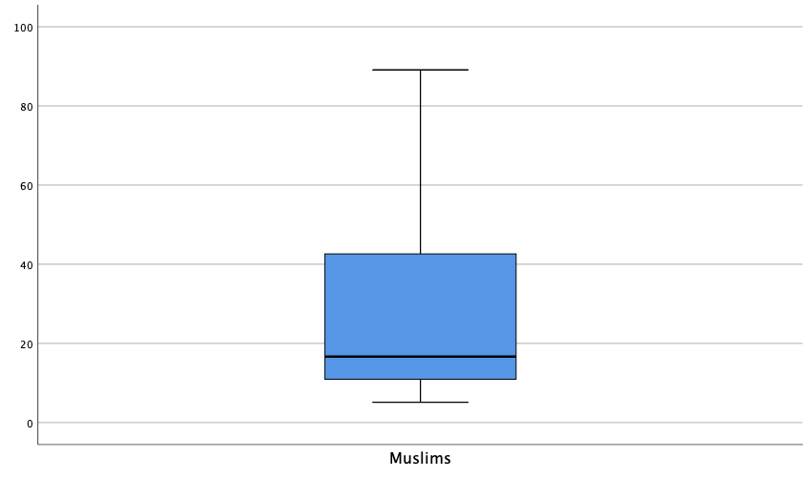

GenPopulation

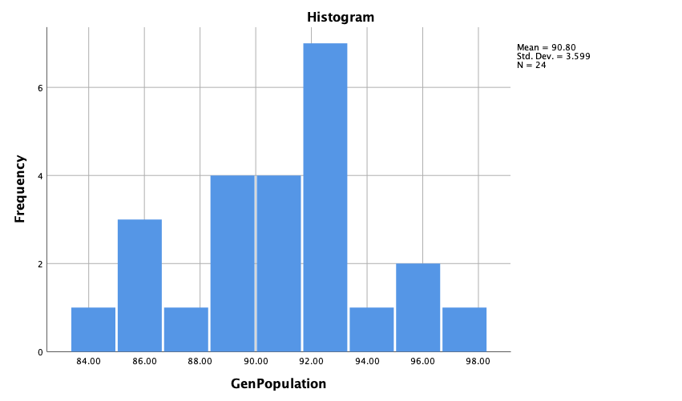

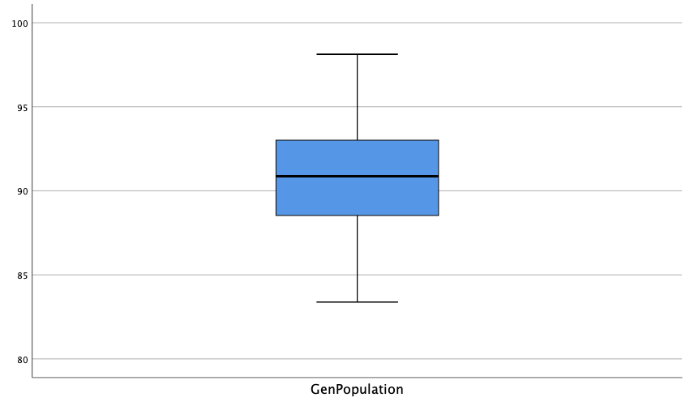

SCPopulation

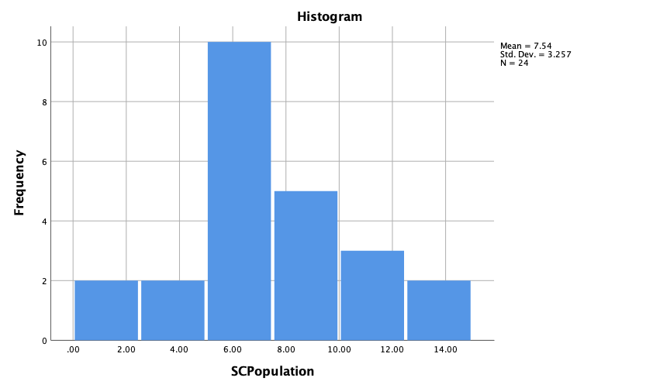

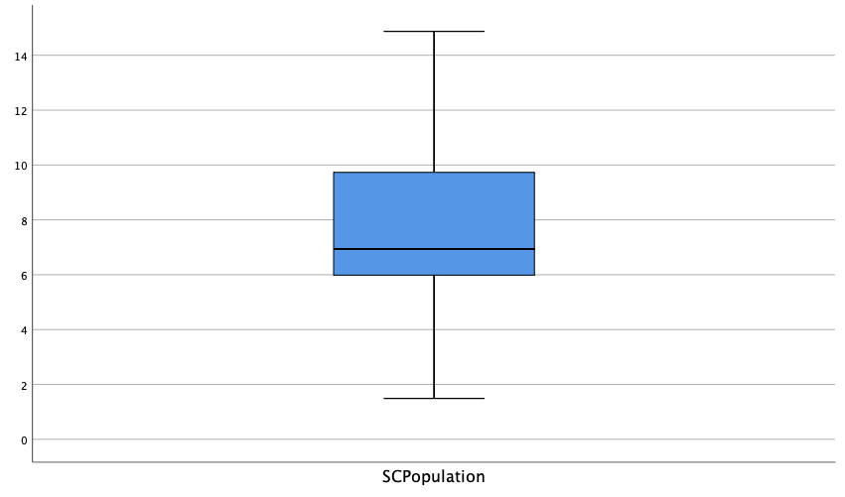

STPopulation

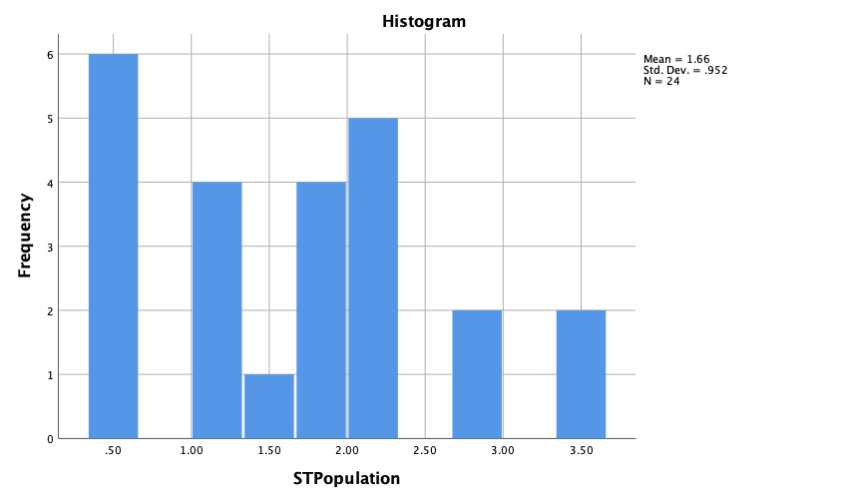

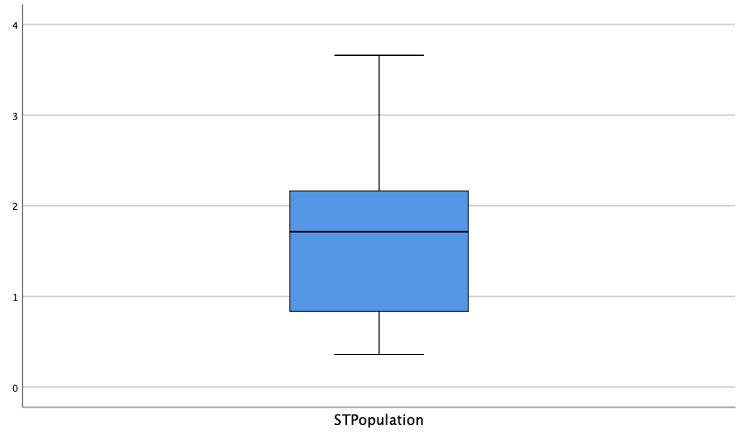

SCSTPopulation

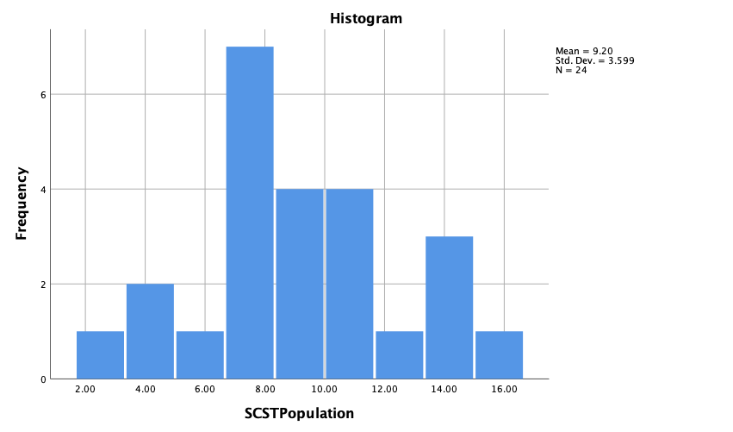

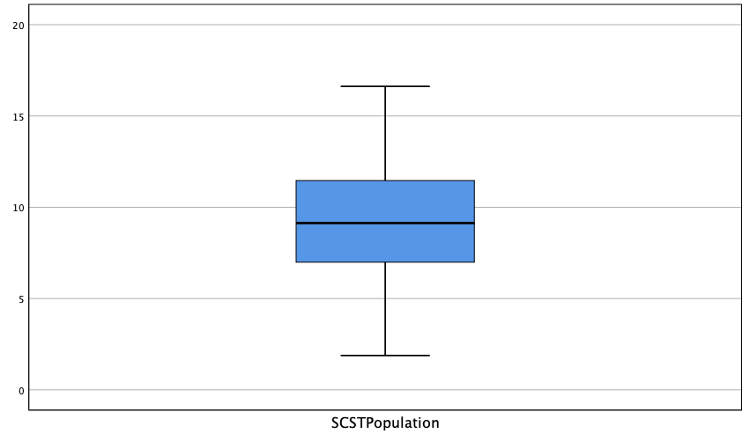

TeluguUrdu

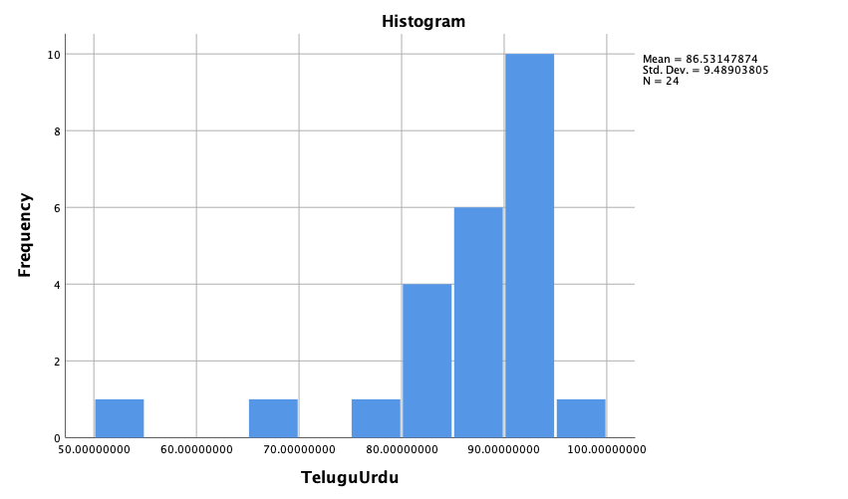

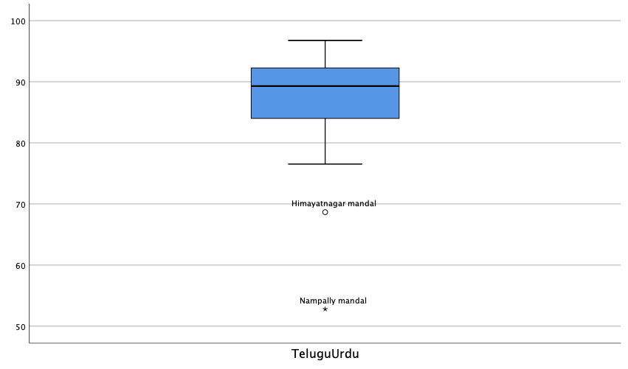

Others

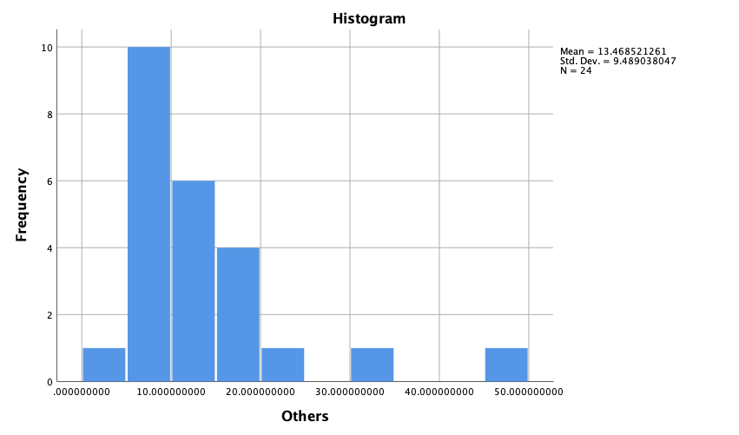

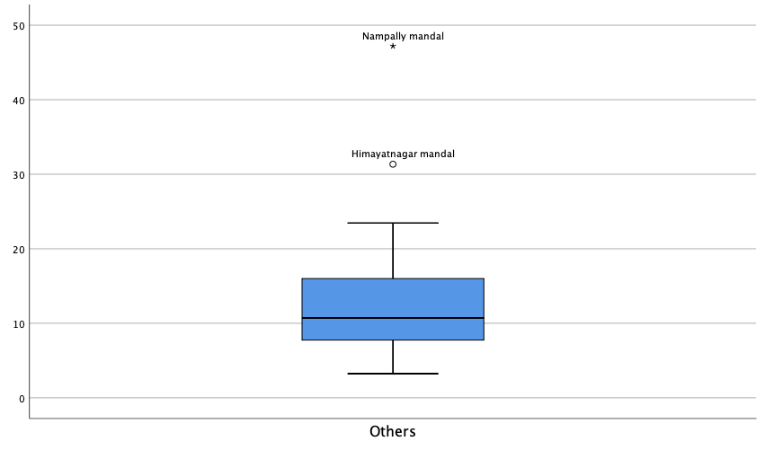

CasteDI

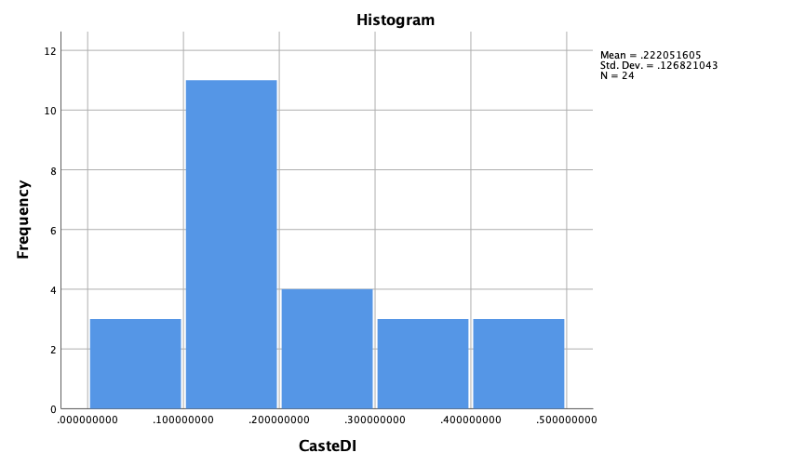

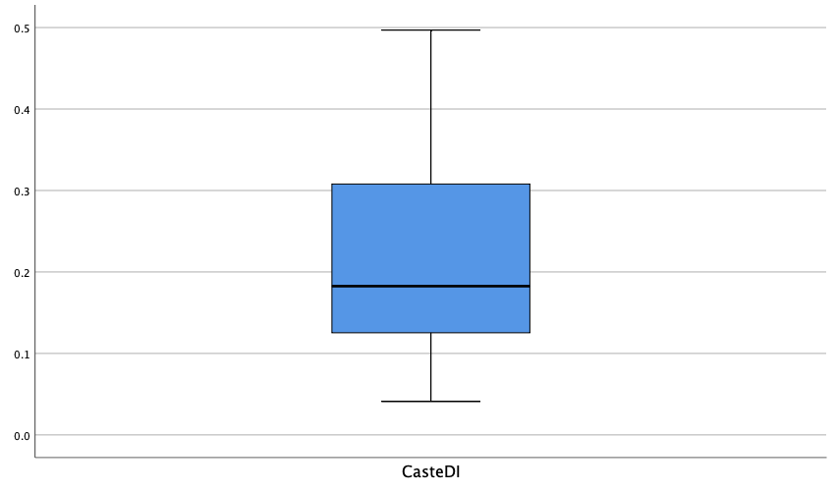

CasteI

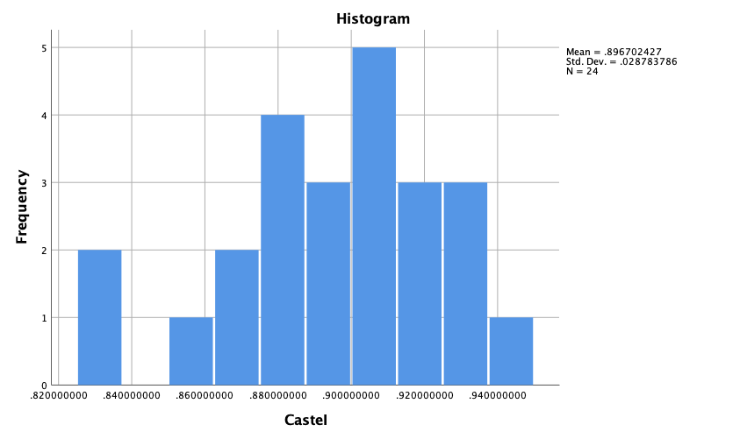

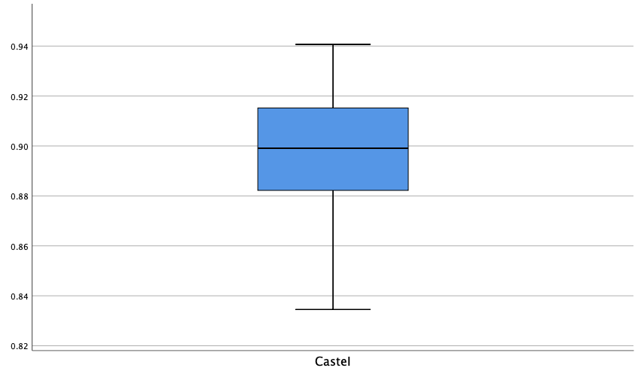

CasteIso

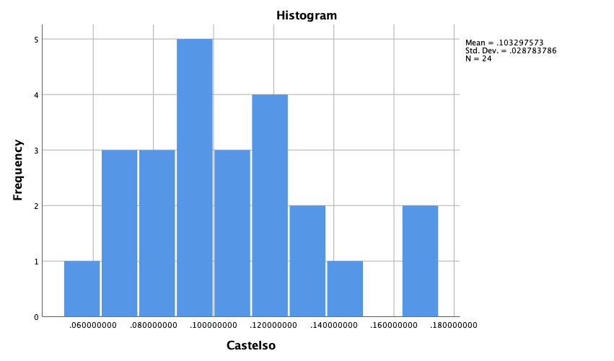

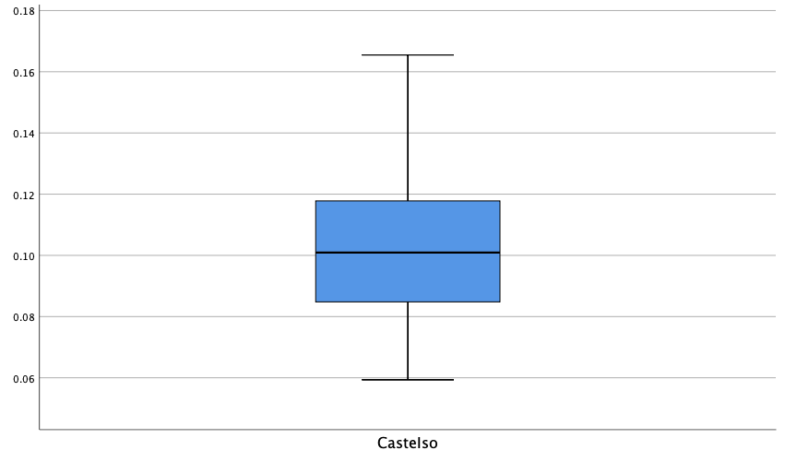

CasteCR

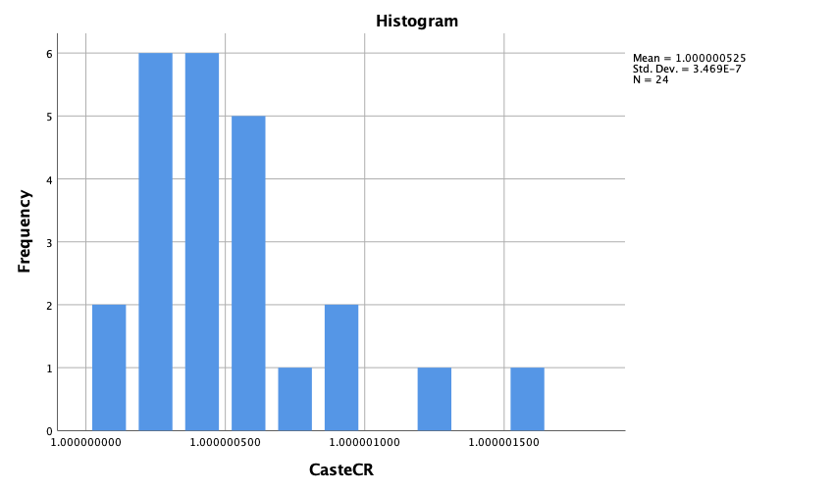

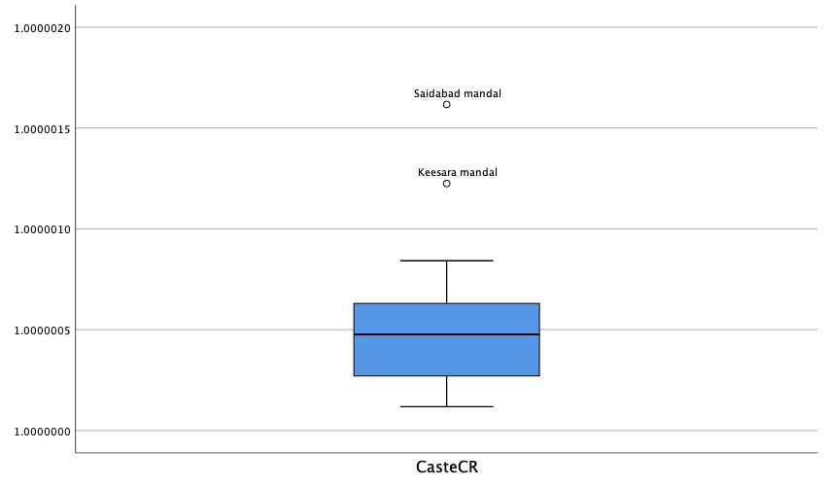

LiteracyDI

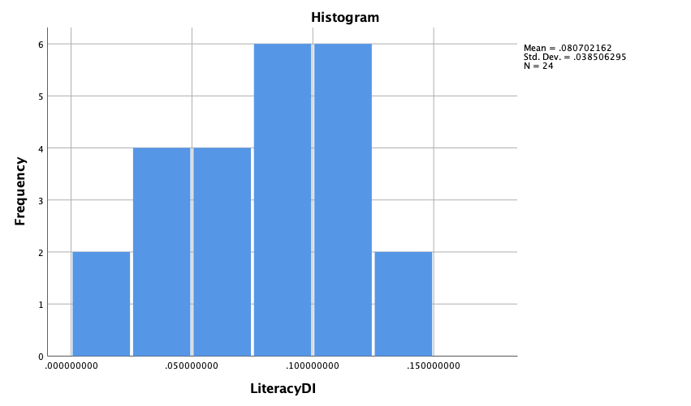

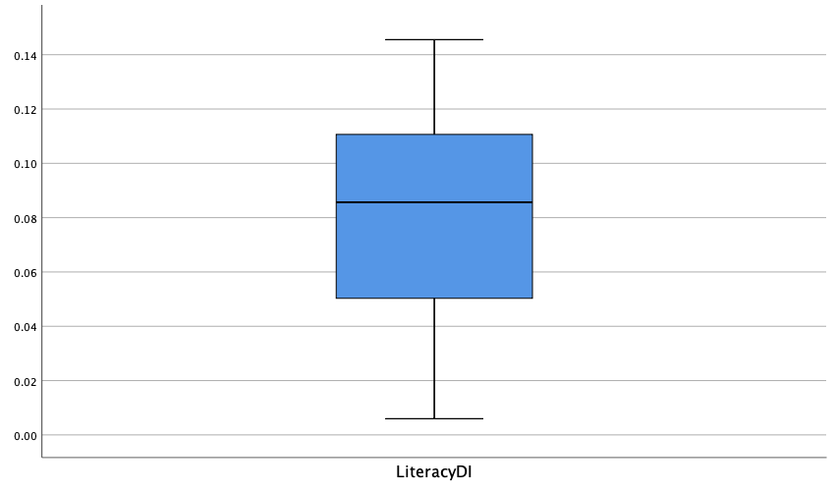

LiteracyI

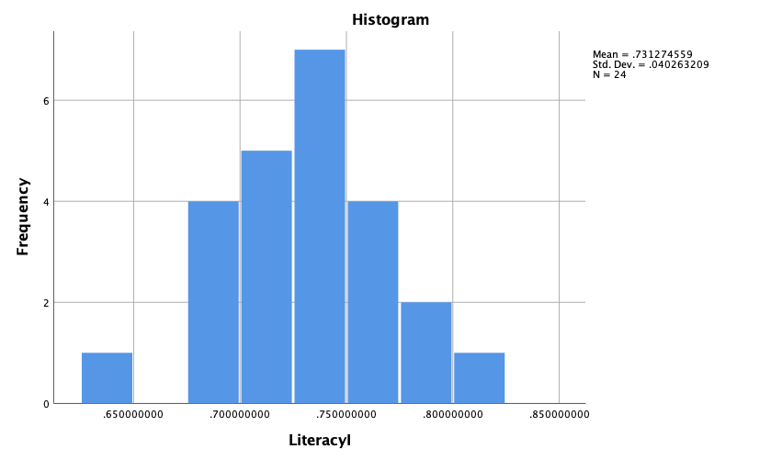

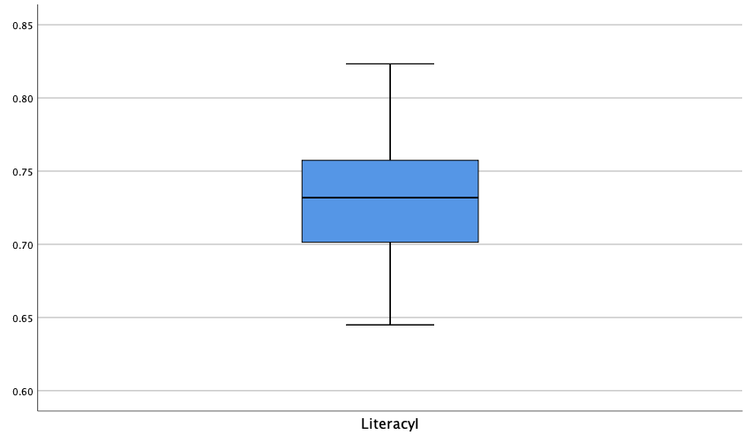

LiteracyIso

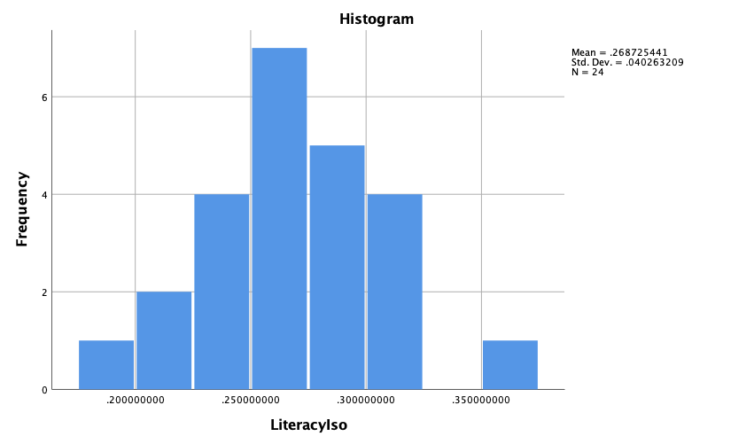

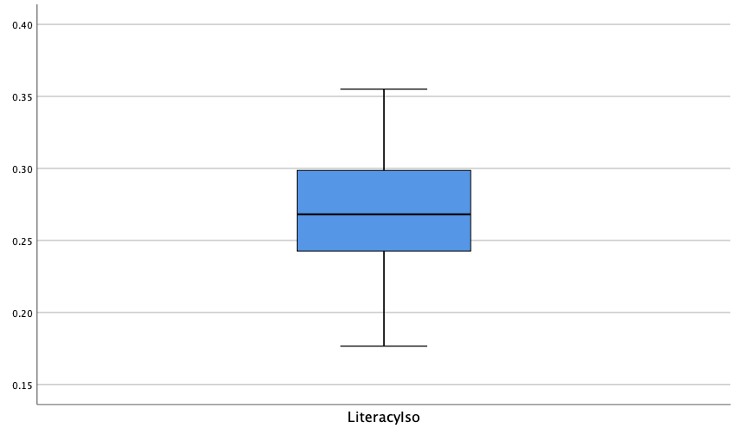

LiteracyCR

